Healthy Heart

Volume-1 | Issue-3 | August, 2009

**Message from Editor's Desk**

As the proportion of people in the age group of 75-80 years increases, the demand for cardiac surgery increases too. The elderly patients and their families alongwith the physicians perceive that such patients may have lower functional reserve and more comorbid conditions, which are more likely to lead to complications or death vis-à-vis younger patients. Thus, cardiologists and cardiac surgeons are hesitant to offer elderly patients lifesaving or symptom-resolving cardiac surgery. However, because of advances in cardiopulmonary bypass technique, myocardial protection, and improved perioperative care, CABG and valve replacement operations can be safely offered to patients. In this edition, we will discuss the risks and benefits of cardiac surgery in elderly patients, describe the advent of new technology, and provide strategies for the management of these patients. **– Dr. Dhiren Shah**

**Cardiac Surgery in Septo and Octogenarians: Who, When, and how?**

**Dr. Keyur Parikh :** Why do you think this topic is so important as to be discussed?

**Dr. Dhiren Shah :** As the longevity of the Indian population is increasing, we find an increase in prevalence of the coronary artery disease and degenerative valvular heart disease. As the number of

elderly patients undergoing CABG surgery and valve replacement continues to increase, evidence is growing that such surgery can result in improvement in health status, functional status, longevity, and quality of life in these patients. Although patients aged 70- 80 years old are at an increased risk for morbidity and mortality because of comorbid conditions such as diabetes mellitus, peripheral vascular disease, and renal dysfunction, especially in urgent or emergent cases, carefully selected patients may continue to lead a full life after recovery from cardiac surgery.

**Dr. Keyur Parikh :** So, do you mean that all elderly patients can undergo cardiac surgery?

**Dr. Dhiren Shah :** Biological aging is quite heterogenous; so precise algorithm or cut off level for age cannot be made. Surgery should be an integrative and an individualized decision based on the timing, general condition of the patient, comorbidities. Several improvements like avoiding urgent surgery, reducing CPB time, not operating on patients in NYHA class IV, can definitely improve the long and short term survival and benefits.

**Dr. Keyur Parikh :** How can morbidity and mortality beimproved in this subset of patients?

**Dr. Dhiren Shah :** Morbidity and mortality can be improved by

* New and improved pharmacological agents
* Operative techniques
* Improved technology
* Advances in cardiac anesthesia
* Myocardial protection during cardiac surgery and in surgical techniques

However, cardiac tissues are often friable, and careful handling of the heart during all aspects of cardiac surgery is essential in elderly patients.

**Dr. Keyur Parikh :** What are the different technologies which can be of help in this subset of patients?

**Dr. Dhiren Shah :** In case of CABG following are the techniques adopted:

1. **Endoscopic Vein Harvesting:** This technique for Harvesting saphenous veins have decreased wound morbidity while preserving vein quality. In a study, wound complications in patients with endoscopic harvesting was (6.8%) than in patients who had open harvesting (28.3%).
2. **Off pump / Beating heart CABG:** is beneficial in case of

* Heavily calcified aortas
* History of impaired renal function with or without dialysis
* History of neurological disease such as transient ischemic attacks and cerebrovascular accidents.

On-pump CABG is associated with systemic inflammatory response and complications include

* Coagulation disorders due to platelet defects and plasmin activation
* Pulmonary dysfunction due to sequestration and degranulation of neutrophils.

Clinical characteristics of the systemic inflammatory response include

* Pathological hypotension
* Fever of noninfectious origin
* Disseminated intravascular coagulation
* Diffused tissue edema and injury
* Multiple organ failure

**(c) Minimally invasive surgery:** In CABG and valvular surgery, introduction of minimally invasive surgery has drastically reduced the blood transfusion rate, hospital stay, and hospital cost, and induced faster recovery and thus quicker return to work. For Coronary artery disease, **Hybrid procedure can be used in elderly patients.**



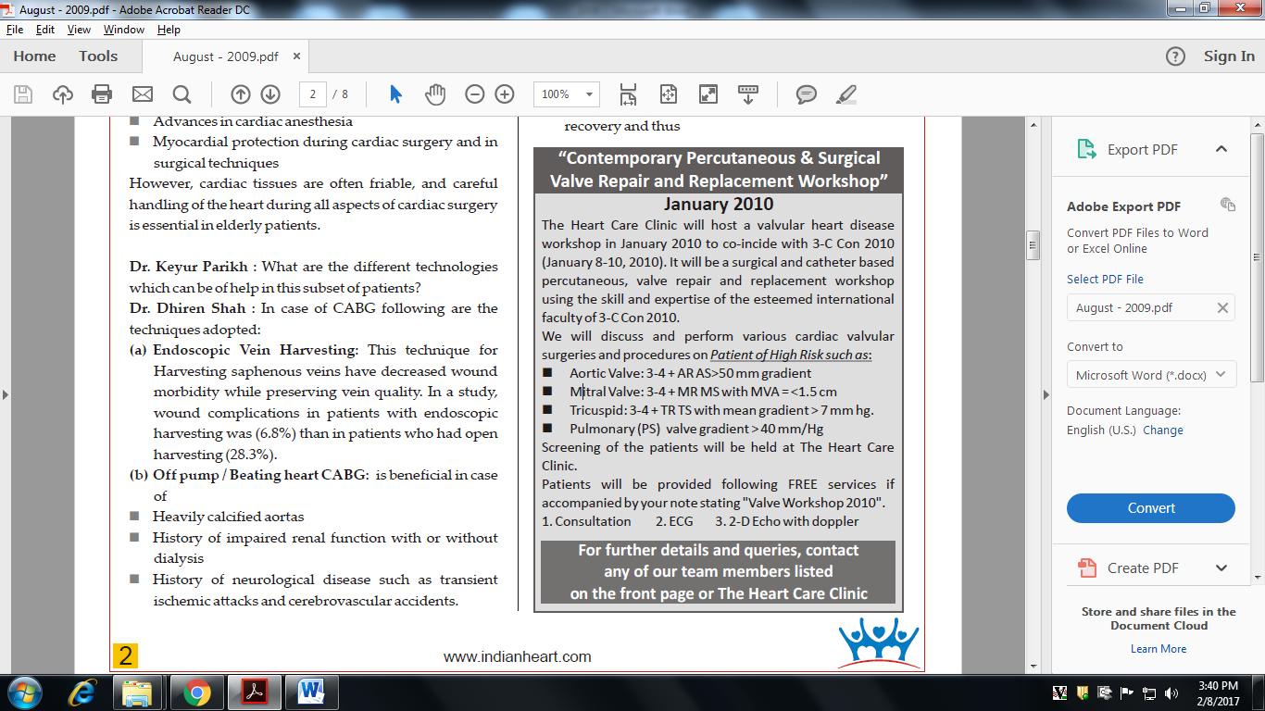

**Dr. Keyur Parikh :** What is ***"Hybrid Procedure"*** and is it done on a routine basis?

**Dr. Dhiren Shah :** Hybrid revascularization entails performing both a PCI procedure and the surgical grafting of the LIMA to the LAD, using a minimally i n v a s i v e a p p r o a c h , typically within one to two days of each other. As there is still no alternative to LIMA to LAD bypass graft with excellent long term results, as practically this graft LIMA to LAD never gets blocked life long.

Stenotic lesion in other coronary artery i.e. LCX & RCA are treated by PTCA or Angioplasty. This trend has started in European countries, with faster recovery and good results and back to work in 2-3 weeks. Now O.T.s are designed with built in cath lab facility so that both can be done simultaneously or in a stage manner.

**Dr. Keyur Parikh :** What are the most common problems of prolonged ICU stay in elderly patients?

**Dr. Dhiren Shah :** In cardiac surgery, the most common outcomes affecting length of stay are atrial fibrillation and pleural effusion. Complications that occur more often in octogenarians than in younger patients are severe low-output state, reintubation, and atrial fibrillation.

1. Atrial fibrillation occurs postoperatively in 30-50% of patients after CABG & Valve surgery, leading to marked morbidity, including hypotension, heart failure, thromboembolic complications, prolonged hospital stay, and increased hospital costs. With advancing age, fibrosis in the atria increases, a situation that leads to side-to-side uncoupling of myocardial fiber bundles and development of nonuniform anisotrophy, ultimately leading to reentrant excitation and atrial fibrillation.
2. Pleural effusion is common after cardiac surgery, occurring in 45-63% of cases. In CABG surgery, pleural effusion occurs primarily as a result of surgical excision of the internal mammary artery, which prevents alveolar expansion and predisposes patients to atelectasis. Treatment is diuresis and/or thoracentesis.



1. Cerebrovascular accidents are important complications of surgery in elderly patients. The increased incidence of strokes is expected in octogenarians because compared to younger patients, the elderly tend to have more advanced cerebral vascular disease, a greater incidence of cerebrovascular accidents, and more advanced aortic arteriosclerosis. Aortic calcification, age, perioperative hypotension, and prolonged bypass time are important determinants of perioperative strokes.

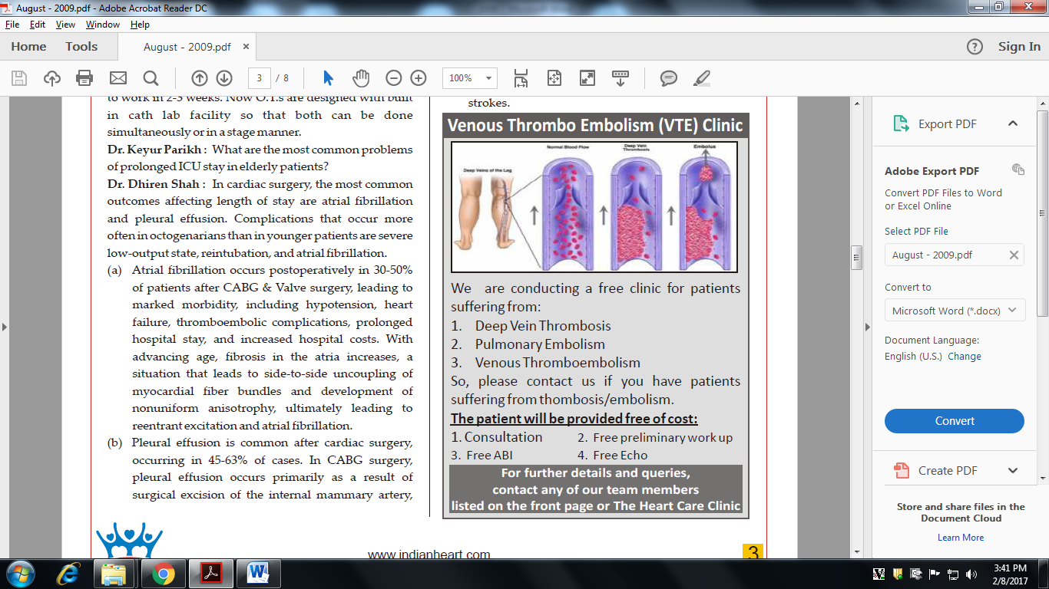

**Dr. Keyur Parikh :** When and how should CABG be performed in octogenarians?

**Dr. Dhiren Shah :** Septuagenarians and Octogenarians referred for cardiac surgery should be evaluated thoroughly for

* Physical fitness
* Medical fitness
* Psychological fitness (people with positive attitude have good outcome), assessment of the disease and its severity.

Also, the efficacy and input of medical management administered has to be considered.

* Unstable angina
* Crescendo angina
* Tight left main disease
* Critical left main equaling disease are the **candidates for surgery with due risk.**

Patient and family should be well educated before surgery about the risks and benefits so that they can independently take the decision without any bias. **Preoperatively,** Chest physiotherapy and exercise should be initiated. Friability of the tissue should be assessed. Antiplatelet drugs should be strictly stopped before 5 days of surgery, so that chances of bleeding are reduced and, thus, also the complications related to the multiple blood transfusions.

**During surgery the following points need to be kept in mind**

* Minimal touch technique
* Non-insistence of multiarterial grafts
* Beating heart surgery, if possible
* Speed in surgery
* Minimally invasive vein harvesting
* Good, clean and haemostatic work

**In post operative care, the following is essential**

* Good analgesia
* Intense physiotherapy
* Early mobilization (the corner stone of better recovery)
* Good psychological support of doctors and families

**Dr. Keyur Parikh :** What does the data indicate as regards feasibility of combined surgeries i.e. CABG + Valve surgery in elderly?

**Dr. Dhiren Shah :** Combined surgery of coronary artery disease and valve surgery definitely has slightly higher mortality and morbidity. Some reports have suggested higher risk in women because of smaller artery, diffused atherosclerosis and late referral because of female gender.

If a coronary artery disease patients has moderate valvular lesion then it is always better to leave the valvular pathology, as the progression of that lesion, is going to be slower in octogenarians, and is going to outnumber the years he is going to survive.

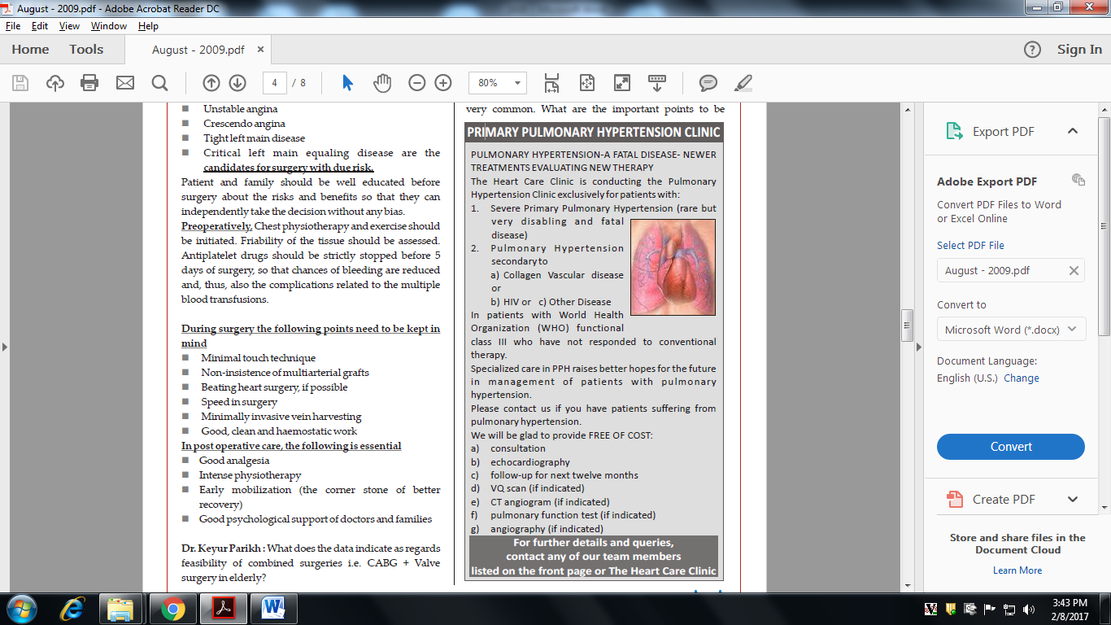

**Dr. Keyur Parikh :** Degenerative Aortic valve disease is very common. What are the important points to be remembered while planning surgery in octogenarians?

**Dr. Dhiren Shah :** The diagnosis of aortic stenosis by physical examination is more difficult in elderly patients. The systolic murmur can be soft, despite severe disease. A slow rising carotid pulse, although quite specific, has a low sensitivity. When a correct diagnosis of significant c a l c i f i e d a o r t i c stenosis has been made, a regular follow-up should i n c l u d e t h e identification of the onset of symptoms or left ventricular dysfunction and a careful Doppler echocardiogram. Predictors of the rate of haemodynamic progression of aortic stenosis in the individual patient are still unknown. Surgery should certainly not be decided on the basis of numbers only, such as mean transaortic gradient or mean valve area in asymptomatic patients > 80 years old. In symptomatic

patients with severe aortic stenosis (valve area < 1 cm2 or 0.62 m-2), aortic valve replacement should, however, be done before development of unstable symptoms and not resorted to as a desperate measure in class IV patients.



**Dr. Keyur Parikh :** Do patients and family education play an important role in the management of elderly patients?

**Dr. Dhiren Shah :** Education of patients and their families is another key component in cardiac surgery. Patients and their families should receive preoperative and postoperative educational materials written by cardiac surgical team to provide a detailed description of cardiac surgery. Physicians should also educate the patients and families and guide them to the proper centre where such surgeries are done with proper expertise and good infrastructural backup. Patients who opt for elective surgery should have a preoperative evaluation in the preadmission test center that includes physical examination, tests, and an educational overview of what to expect before and after surgery.

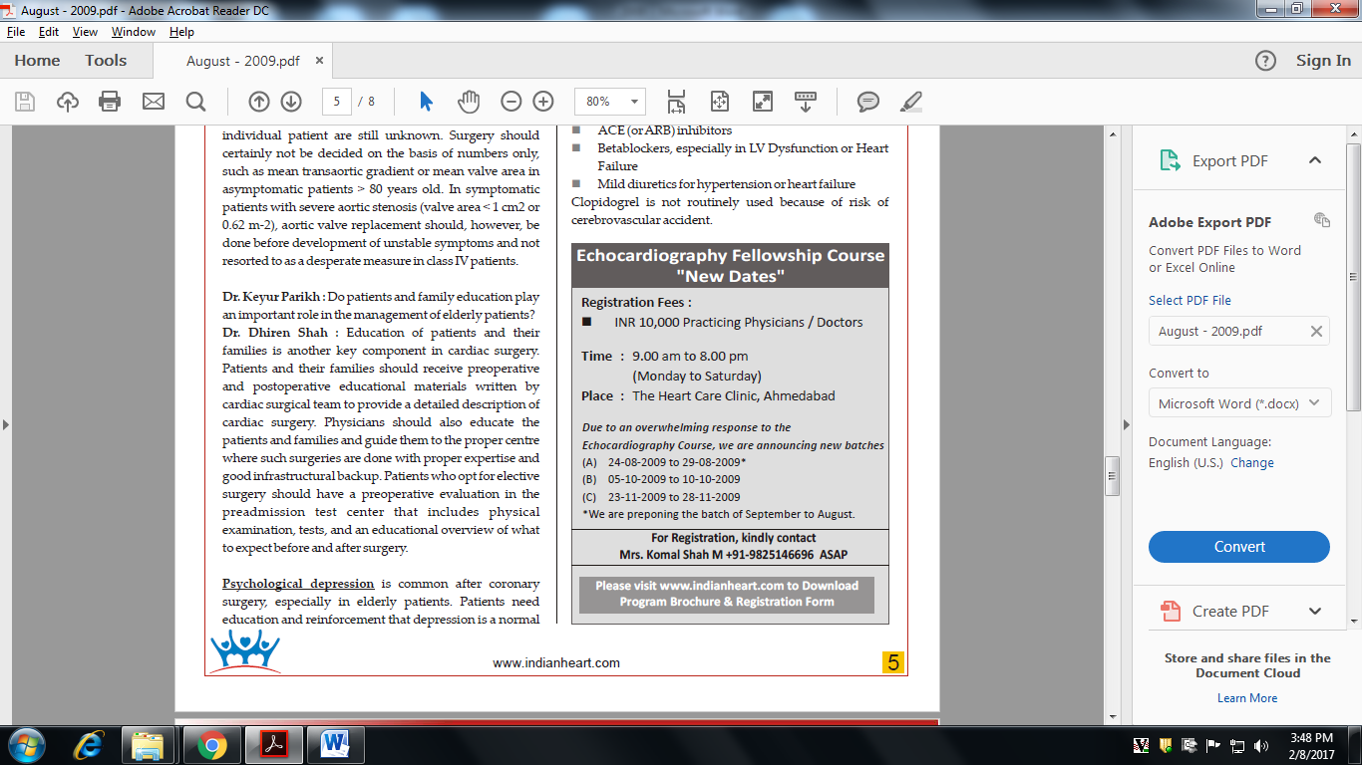**Psychological depression** is common after coronary surgery, especially in elderly patients. Patients need education and reinforcement that depression is a normal response to a major cardiovascular event. Elderly patients also have an increased incidence of noncompliance with their medications.

**Poor compliance of elderly patients is due to**

* Costly drugs
* Use of multiple drugs
* Mental Impairment
* Visual and hearing disabilities
* Living on one's own

Discharge planning is an integral part of patients' hospitalization for cardiac surgery alongwith good exercise training.

Following medicines are routinely prescribed after CABG in these patients:

* Aspirin
* Statins
* ACE (or ARB) inhibitors
* Betablockers, especially in LV Dysfunction or Heart Failure
* Mild diuretics for hypertension or heart failure Clopidogrel is not routinely used because of risk of cerebrovascular accident.