Healthy Heart

**Volume-6 | Issue-68 | July 5, 2015**

***From the Desk of Hon. Editor:***

*Dear Friends, Coronary artery disease is one of the most common & is rampant in Indian population. In the CAD disease spectrum, the most deadly complications of myocardial*

*infarction are post MI VSD, Mitral Regurgitation & LV rupture. Post MI VSD is an entity if diagnosed early & treated aggressively in time can save life of the majority of patients. In this era morbidity & peri operative mortality is still high. But important point is this catastrophic complication of MI is treatable & can be cured with reasonable risks.* ***– Dr. Dhiren Shah***

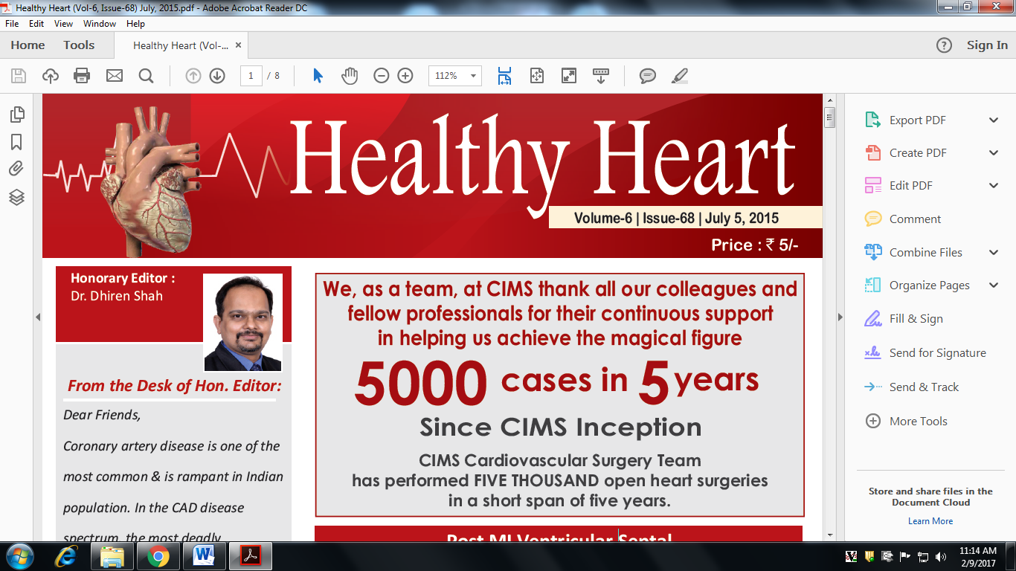

**Post MI Ventricular Septal Rupture – Deadly Complication**

Ventricular septal rupture (VSR) is a rare but lethal complication of myocardial infarction (MI). The event occurs 2-8 days after an infarction and often precipitates cardiogenic shock. The differential diagnosis of postinfarction cardiogenic shock should exclude free ventricular wall rupture and rupture of the papillary muscle.

In current practice, postinfarction VSR is recognized as a surgical emergency, and the presence of cardiogenic shock is an indication for intervention. Long-term survival can be achieved in patients who undergo prompt surgery. Concomitant coronary artery bypass grafting (CABG) may be required. The addition of CABG has helped improve long-term survival.

Surgery is performed via a transinfarction approach, and all reconstruction is performed with prosthetic materials to avoid tension. Developments in myocardial protection and improved prosthetic materials have contributed greatly to successful management of VSR. Improved surgical techniques (eg, infarctectomy) and better perioperative mechanical and pharmacologic support have helped lower mortality. In addition, the development of surgical techniques to repair perforations in different areas of the septum has led to improved results. In current practice, patients undergoing shunt repair tend to be older and are more likely to have received thrombolytic agents, which may complicate repair. After successful repair, survival and quality of life are excellent, even in patients older than 70 years.

**Pathophysiology**

The septal blood supply comes from branches of the left anterior descending c oronary artery, the posterior descending branch of the right coronary artery, or the circumflex artery when it is dominant. Infarction associated with a ventricular septal rupture (VSR) is usually transmural and extensive. About 60% of VSRs occur with infarction of the anterior wall, 40% with infarction of the posterior or inferior wall (see the image below). Posterior VSR may be accompanied by mitral valve insufficiency secondary to papillary muscle in farction or dysfunction.

The natural history of postinfarction VSR is greatly influenced by hypertension, anticoagulation therapy, advanced age, and, possibly, thrombolytic therapy. The natural course in patients with postinfarction VSR is well documented and short. Most patients die within the first week, and almost 90% die within the first year; some reports indicate that fewer than 7% of patients are alive after 1 year.

This grim prognosis results from an acute volume overload exacted on both ventricles in a heart already compromised by a large MI and occasionally by extensive coronary artery disease (CAD) in sites other than that already in farcted. In addition, superimposed ischemic mitral valve regurgitation, a ventricular aneurysm, or a combination of these conditions may be present, further compromising heart function. The depressed left ventricular function commonly leads to impaired peripheral organ perfusion and death in most patients.

A few sporadic reports indicate that some patients with medically treated postinfarction VSR live for several years. Although many medical advances have been made in the nonsurgical treatment of these patients, including intra-aortic balloon counterpulsation (IABCP), these methods have not eliminated the need for surgery.

**Prognosis**

Operative mortality is directly related to the interval between myocardial infarction (MI) and surgical repair. In a retrospective analysis of 41 patients treated for postinfarction VSD, Serpytis et al confirmed that whereas female sex, advanced age, arterial hypertension, anterior wall acute MI, absence of previous acute MI, and late arrival at hospital were associated with a higher risk of mortality from acute VSD, the time from the onset of AMI to operation was the most important factor determining operative mortality and intrahospital survival.

If repair of a postinfarction VSR is performed 3 weeks or more after the infarction, mortality is approximately 20%; if it is performed before this time, mortality approaches 50%. The most obvious reason for this is that the greater the degree of myocardial damage and hemodynamic compromise, the more urgent the need for early intervention.

With the use of an early operative approach, most studies show an overall mortality of less than 25%. Mortality tends to be lower for patients with anteriorly located ventricular septal ruptures (VSRs) and lowest for patients with apical VSRs. For anterior defects, mortality ranges from 10% to 15%; for posterior defects, mortality ranges from 30 % to 35 %.

More than 50% of deaths occurring after surgery for postinfarction VSR are due to cardiac failure. Sudden death is rare, and intractable heart failure can also occur. Other causes of death include cerebral embolism. Most patients who survive the hospital period have good functional status, with the majority falling into New York Heart Association (NYHA) class I or II. The most important risk factors for death i n t h e e a r l y p h a s e a r e p o o r hemodynamics and associated right ventricular dysfunction developing before the patient comes to the operating room. The amount and distribution of myocardial necrosis and scarring are responsible for both.

Right ventricular dysfunction results from ischemic damage or frank infarction of the right ventricle and is present when stenosis occurs in the right coronary artery system. The higher mortality observed after repair of defects located inferiorly in the septum is probably related to the higher prevalence of important right coronary artery stenosis. The severity and distribution of coronary artery disease (CAD) are also risk factors. Similarly, advanced age at operation, diabetes, and preinfarction hypertension are risk factors for death in the early phase.

Risk factors for death in patients with postinfarction VSR may be summarized as follows:

* Posteriorly located VSRs are technically more difficult to repair and are associated with profound right ventricular dysfunction.
* The presence of multiple organ failure is a poor prognostic factor.
* The presence of cardiogenic shock does not bode well for the patient's survival.
* A shortened interval between infarction and surgery usually indicates that the patient is considered more ill and therefore is at greater risk for death.

In a retrospective analysis of 52 consecutive patients with surgically repaired postinfarction VSR over a 30- year period (mean follow-up, 7.8 ± 7.7 years), Takahashi et al found that predictors of 30-day mortality on univariate analysis included the following :

* Renal insufficiency
* Shock at surgery
* Emergency surgery
* Logistic EuroSCORE
* Three-vessel disease
* Significant left circumflex coronary arterial stenosis
* Significant right coronary arterial stenosis
* Incomplete revascularization
* Surgical duration
* Cardiopulmonary bypass time

On multivariate analysis, only incomplete coronary revascularization was an independent risk factor for 30-day mortality.

**Treatment & Management**

**Medical therapy**

Initiate pharmacologic therapy in an attempt to render the patient hemodynamically stable. The goals are to reduce afterload on the heart and to increase forward cardiac output.

Vasodilators may be used in an attempt to decrease the left-to-right shunt associated with the mechanical defect and thereby increase cardiac output. Intravenous (IV) nitroglycerin can be used as a vasodilator and may provide improved myocardial blood flow in patients with significant ischemic cardiac disease.

When used alone, inotropic agents may increase cardiac output; however, without changes in the ratio of pulmonary to systemic flow (Qp-to-Qs ratio), they markedly increase left ventricular work and myocardial oxygen consumption. The profound level of cardiogenic shock in some patients precludes vasodilator treatment, often necessitating vasopressor support.

Vasopressors markedly increase left ventricular work and myocardial oxygen consumption. They also increase systemic afterload and further increase the Qp-to-Qs ratio, thus lowering cardiac output and greatly augmenting myocardial oxygen consumption.

Intra-aortic balloon counterpulsation (IABCP) offers the most important means of temporary hemodynamic support. IABCP reduces left ventricular afterload, thus increasing systemic cardiac output and decreasing the Qp-to-Qs ratio. IABCP also facilitates diastolic augmentation with an increase in coronary blood flow, resulting in an improved oxygen supply. IABCP is not a substitute for urgent intervention, and in patients with cardiogenic shock, it should be followed by immediate intervention. Patients with ventricular septal rupture (VSR) do not die of cardiac failure; they die as a result of end-organ failure. Only by shortening the duration of shock, can the high risk of mortality be prevented.

Achieving hemodynamic stability before surgery is very beneficial, but prolonged attempts to improve the patient's hemodynamic status can be hazardous.

This aggressive approach often results in temporary stability of these extremely ill patients. As a rule, however, these benefits are brief, and patients may deteriorate rapidly. Therefore, early diagnosis and rapid surgical intervention should be planned. Only about 10-15% of patients can be treated with conservative measures for a period of 2-4 weeks, after which surgical treatment can be provided at a greatly reduced risk.

**Operative therapy Indications and contraindications**

In view of the grim prognosis for medically treated patients, the diagnosis of postinfarction VSR, by itself, constitutes an indication for operation.

The controversy that once surrounded the timing of surgical intervention is no longer an issue, and most surgeons now agree that early surgery is indicated to minimize the risk of mortality and morbidity. The success of surgical therapy depends on prompt medical stabilization of the patient and prevention of cardiogenic shock.

The relative safety of repair 2-3 weeks or more after perforation has been established. Because the edges of the defect have become firmer and fibrotic, repair is more secure and is easily accomplished. A successful clinical outcome is related to the adequacy of the closure of the VSR; therefore, if possible,

search for multiple defects both preoperatively and at the time of surgery.

**Choice of operative approach**

Different Operative technique are available to treat this difficult surgery, like

1. Infarct exculsion technique
2. Double sandwich [ patch ] technique
3. Bono technique
4. Right atrial approach
5. Right ventricular approach

Additional procedures that may be considered in the treatment of postinfarction VSR include the following:

* Concomitant coronary artery bypass grafting (CABG)
* Mitral valve replacement
* Excision of left ventricular aneurysm

Patients who require an intra-aortic balloon pump preoperatively appear to benefit from postoperative support with the device for 24-72 hours. Some of these patients demonstrate a small persistent or recurrent left-to-right shunt. Because of the large amount of prosthetic material used to repair the septal perforation, anticoagulation therapy in these patients is recommended by some surgeons for a period of 6-8 weeks.

Residual VSDs have been noted early or late after operative treatment in 10-25% of patients. These residual defects are easily diagnosed with the aid of colorflow Doppler investigations. Residual VSDs may be attributable to the reopening of a closed defect, the presence of an overlooked VSD, or the development of a new septal perforation during the early postoperative period. Reoperation is required for closure of such residual VSDs when the Qp-to-Qs ratio is greater than 2. When the VSDs are small and asymptomatic, a conservative approach may be recommended because spontaneous closure can occur.

**Percutaneous treatment**

Data collected by the Society of the Thoracic Surgeons National Database indicate that postinfarction VSD is a lethal disorder, even with treatment. The hope is that some type of percutaneous interventional technique may be developed in future to close the ruptured VSD and lower the mortality. Isolated reports with the Amplatzer Septal Occluder (St Jude Medical, St Paul, MN) found the technique to be safe for closure of small lesions.